Acoustic Emission Dataset – PD Tests

Wenjie Tu

This dataset contains AE data from 4 planar delamination tests, as described in Table 1.

Table 1 Details of groups of PLB tests.

|  |  |  |  |  |  |
| --- | --- | --- | --- | --- | --- |
| Label | Number of sensors | Layup | Specimen type | Sensor distribution | Number of tests |
| PCLO_QI00 | 4 | QI | PCLO | Square | 1 |
| PCLO_QI090 | 4 | QI | PCLO | Parallelogram | 1 |
| PCLSR_QI00 | 4 | QI | PCLS | Square | 1 |
| PCLSR_QI090 | 4 | QI | PCLS | Parallelogram | 1 |

Note: QI is an abbreviation of Quasi-Isotropic, and CP is for Cross-Ply. The ‘090’ indicates the mid interface where the defect is embedded. The size of the full panel is 400×400mm (length × width). The PCLO and PCLS specimens are of 140×140mm.

The specimen configuration and sensor distribution are shown in Figure 1.

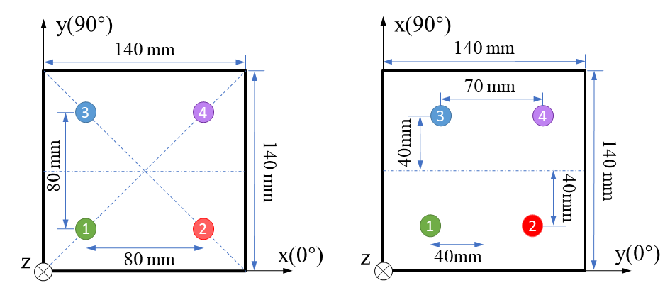

**PCLSR_QI00 PCLSR_QI090**

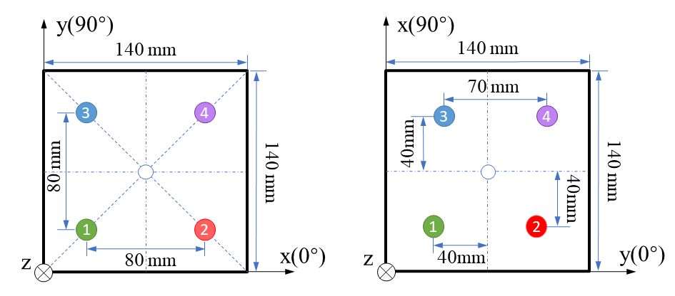

**PCLO_QI00 PCLO_QI090**

Figure 1 Illustration of the specimen configuration and sensor distribution